Application Report
Name – Mehul Vashisth
Registeration no.- 25BAI11510
Faculty – Prof. G.Ganesan
Topic- Library Management System
Problem statement
- Managing all the books available in library can be difficult for a librarian thus Causing many books to go missing without information.
Project Objective
- The following project involves a digital program to help the librarian with same storing digital record of where all the books are and with whom when issued.
- The program uses different functions which are called during the main program according to the requirement of the librarian (ex. To add books, to issue books, etc.).
- This Document aims to provide an in-depth overview of the Project.
Functional requirements
- Add new books with details (title, author, ISBN)
- List all available books
- Search for books by ISBN
- Delete books from the system
- Register new users
- Issue books to registered users
- Return issued books to the library
- Display all currently issued books
- Exit the system safely
Non-functional Requirements
- User-friendly command-line interface
- Efficient data storage in memory using lists for quick access
- Real-time updates to book and user status
- Robust input handling and error messaging
- Maintainable and extendable codebase

System Architecture
The system follows a procedural programming architecture with global variables managing data storage. The main interaction happens through a menu-driven loop, invoking respective functions for CRUD (Create, Read, Update, Delete) operations on books and users.
Process Flow or Workflow Diagram

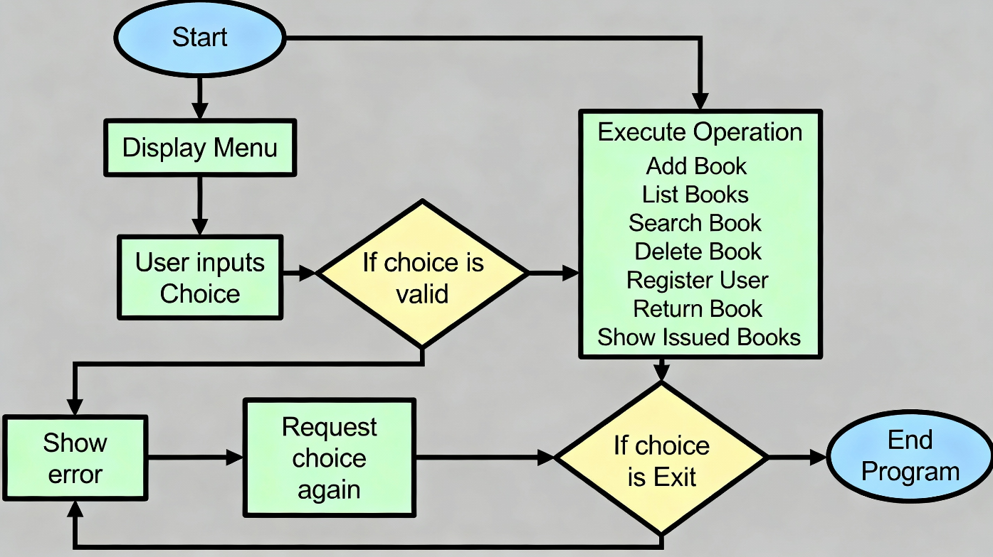
Design Decisions & Rationale
- Programming Paradigm: The system was implemented using procedural programming in Python for simplicity and ease of understanding. This choice was made because the project is introductory and focused on core library functionality without object-oriented complexities.
- Data Storage: Lists were used to store books, users, and issued books as global variables. This approach allows dynamic addition and deletion with straightforward iteration for searches and updates. Although simple, this model suits the project’s scope well.
- Unique Identifiers: The ISBN number was selected as the unique identifier for books to ensure each book can be distinctly identified when searching, issuing, or deleting. Usernames uniquely identify registered users.
- User Interface: A command-line menu-driven interface offers a lightweight and accessible way to interact, suitable for the intended users and testing environment without the need for a graphical interface.
- Function Structure: Each key operation (add, list, search, delete, register, issue, return) was encapsulated in its own function. This modular design supports easy debugging and potential future expansion.
- Error Handling: Basic input validation and feedback (such as checking if books or users exist before issuing or deleting) was implemented to maintain data integrity and improve user experience.
- Scalability Consideration: While current data structures are simple and held in-memory, this setup serves as a prototype. Future improvements could include object-oriented design and persistent data storage.

Implementation Details
The Library Management System is implemented in Python. The primary elements are:
- Global Lists:
  - Books: stores book dictionaries with keys title, author, and isbn.
  - users: stores usernames as strings.
  - issuedbooks: stores book dictionaries currently issued to users.
- Functions:
  - addbook(): Prompts for details and appends a new book to Books.
  - listbooks(): Prints the current list of books available in the library.
  - searchbooks(): Searches Books by ISBN and displays the book if found.
  - deletebooks(): Deletes a book from Books by ISBN if it exists.
  - registeruser(): Adds a new username to users.
  - issuebooks(): Issues a book by ISBN to a registered user, moving the book from Books to issuedbooks.
  - returnbooks(): Returns a book by moving it back from issuedbooks to Books.
  - main(): Drives the program loop; displays the menu, takes user choices, and calls respective functions.
- Control Flow:
The program runs an infinite loop inside the main() function, allowing continuous user input until exit is chosen. Each menu choice triggers the corresponding function.
- Data Handling & Integrity:
Before issuing or deleting books, and before issuing or returning books, the system checks for the existence of users and books, preventing invalid operations.
- User Feedback:
Throughout the process, informative messages confirm actions or highlight errors (e.g., "Book not found," "User registered successfully").
- This implementation forms a foundational LMS and can be extended with better data handling and user interfaces.
Testing Approach
- Manual Testing: The system was tested manually through the command-line interface by running various scenarios.
- Functional Testing: Each function (add, list, search, delete, register, issue, return) was tested independently for correct behavior.
- Boundary Cases: Tests included searching and deleting non-existent books, issuing books to unregistered users, and returning books not currently issued.
- Validation: Input validations ensured only correct data manipulated the system state.
- Iteration Testing: Multiple sequences of issue and return operations were performed to verify the integrity of Books and issuedbooks lists.
- User Interaction: The main menu selection was tested for invalid and valid inputs, ensuring smooth operation without program crashes.

Challenges Faced
- Managing the integrity of book records between Books and issuedbooks lists required careful update and removal operations.
- Ensuring that only registered users could issue or return books demanded consistent user validation.
- Handling invalid inputs and presenting meaningful feedback was essential to maintain usability and system stability.
- Without persistent storage, all data is lost upon program termination; designing a persistent solution was outside the project scope but noted as a challenge.
- Using global variables and lists made it prone to errors in complex scenarios but was suitable for this project's scale.

Learnings & Key Takeaways
- Gained practical experience in organizing a menu-driven CLI application with modular functions.
- Understood the importance of unique identifiers (ISBN) and robust input validation.
- Learned basic concepts of system state management, with data separation between available and issued books.
- Developed debugging and testing skills for interactive console programs.
- Recognized limitations of in-memory data handling and the potential need for object-oriented restructuring and database integration.

Future Enhancements
- Object-Oriented Design: Refactor the code using classes like Book, User, and Library to improve scalability and maintainability.
- Persistent Storage: Integrate file handling or a database (e.g., SQLite) to save data across sessions.
- Graphical User Interface: Develop a GUI for better user experience using libraries like Tkinter or PyQt.
- User Roles & Authentication: Implement role-based access (admin, member) and login functionality.
- Advanced Search: Allow searching by title, author, or partial matching, not just ISBN.
- Notifications: Add reminders for overdue books and fine management.
- Bulk Operations: Enable batch import/export of books or users.

References
- Python Official Documentation - https://docs.python.org/3/
- GeeksforGeeks: Introduction to Python Programming - https://www.geeksforgeeks.org/python-programming-language/
- TutorialsPoint: Python Tutorial - https://www.tutorialspoint.com/python/index.htm
Screen Shots
